Report of all Wednesday Afternoons timetabled sessions 2017/18
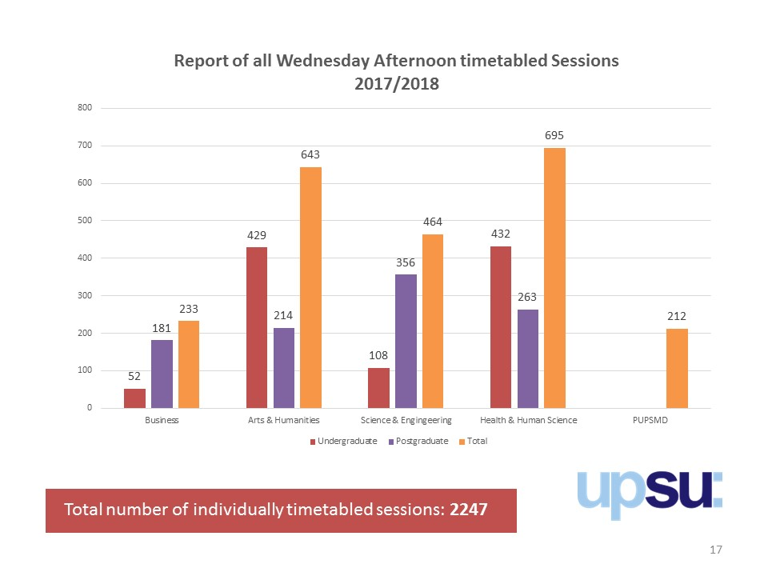

Faculty of Business
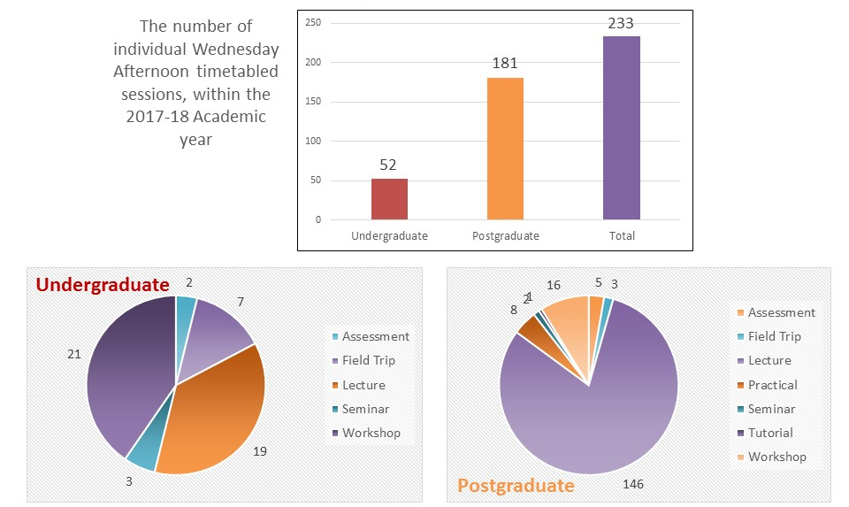

Faculty of Arts & Humanities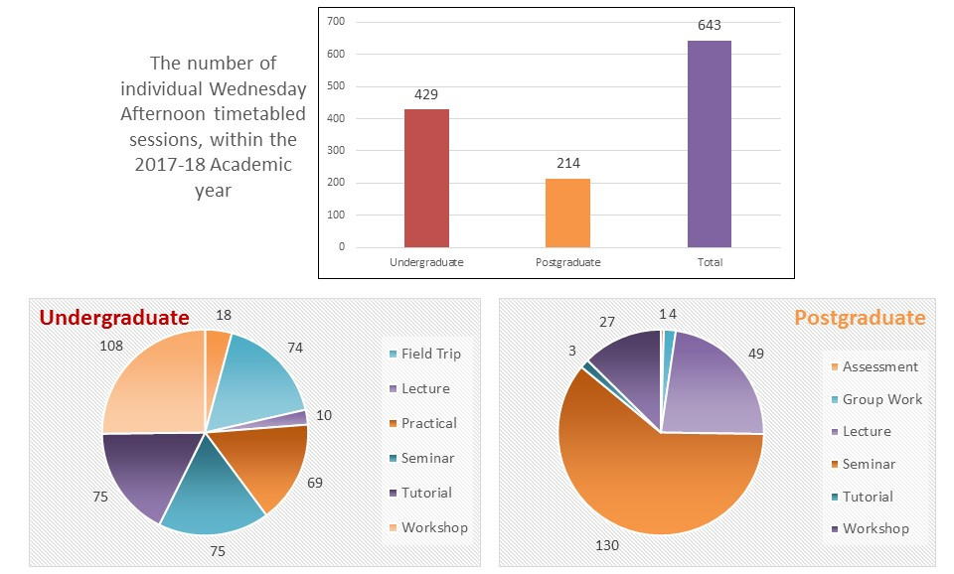

Faculty of Health & Human Sciences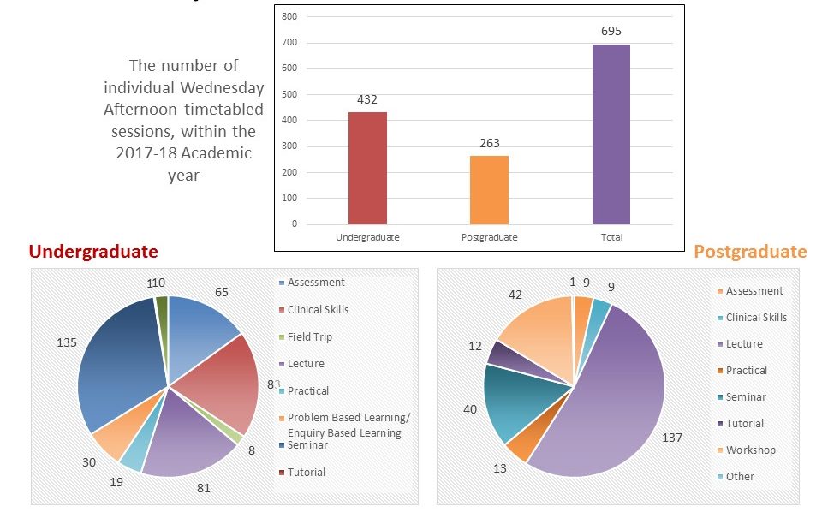

Faculty of Science & Engineering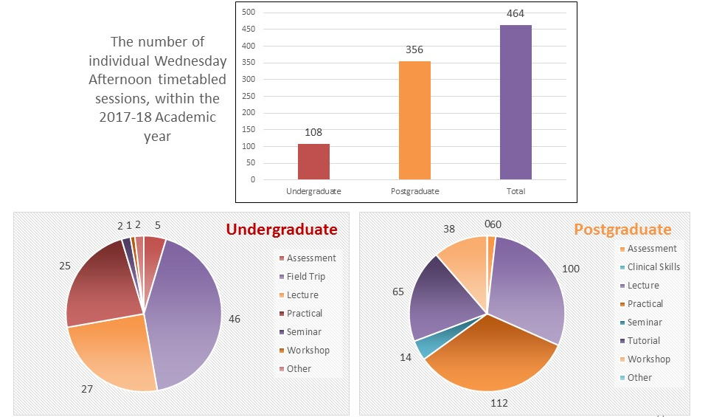

PUPSMD- (didn’t have the information for postgrad/ undergraduate study)
